This manual provides a brief guide on how to log in and how to access our project.

**1. Login Process**

To log in and access the home page, follow these steps:

**Enter Credentials:**

**Email:** Provide your registered email address.

**Password**: Input your password.

**Submit:** Click the "Submit" button.

Upon successful authentication, you will be automatically redirected to the home page.

**2.Customer Registration:**

In the 'Customer Registration' section, there are two submodules: 'Add Customer' for adding new customers and 'Customer List' for managing and viewing the list of registered customers.

Add Customer:

In the 'Registration' submodule, please ensure that you fill in all the mandatory fields marked with an asterisk (*) symbol, as these are required fields. In certain cases, you can either choose to upload a file or use your webcam for the required action. After completing the registration process, you will be redirected to the 'Customer List' page.

Customer List:

After being redirected to the 'Customer List' page, you will find a table displaying all the customer listings. In the last cell of each row, there are three action icons:

* The eye icon, which represents the 'View' option. Clicking this icon allows you to view the details of the customer.
* The pencil icon, which represents the 'Edit' option. Clicking this icon enables you to edit the customer's information.
* The trash bin icon, which represents the 'Delete' option. Clicking this icon allows you to delete the customer's record."

**3.LOAN PROCESS:**  
In the "Loan Process," there are three submodules: "Loan Approval," "Loan List," and "Repayment."

**Loan Approval:**

The loan approval process typically involves several steps or stages to assess a borrower's eligibility for a loan. The three processes you mentioned, personal detail, jewel detail, and approval data, seem to represent different stages or components of the loan approval process.

* After completing all the details in the form shown in the image above, click the 'Next' button.

* After clicking 'Next,' you will be redirected to the jewel detail page. Here, you can fill in all the details about the jewel and use the 'Capture' button to capture the image of the jewel. To add additional jewels, click the 'Add Jewel' button, which will open a new table for you to fill in the details.

Afterward, you will be directed to the approval data page, where a cash denomination page will be available. Please note that if you enter an amount that is too low, the button will become disabled. Next, click the 'Submit' button to proceed.

Loan List:

After being redirected to the 'Loan List' page, you will find a table displaying all the loan listings. In the last cell of each row, there are two action icons:

* The eye icon, which represents the 'View' option. Clicking this icon allows you to view the details of the loan.
* The trash bin icon, which represents the 'Delete' option. Clicking this icon allows you to delete the loan record."

Repayment:

In the 'Repayment' module, there are three options available: 'Part Payment', 'settlement’ and 'Interest Calculator’

In the images displayed above, there is a dropdown text field that shows all the customer loan details. When you select a specific ID from the dropdown, the transactions for that customer are displayed in the table

Part payment

After clicking the 'Part Payment' button, a new pop-up tab will appear, similar to the image shown below. If the payment is made after the loan disbursement date, it calculates the interest and one time refresh the page after checking.

Next, click the 'Part Payment' button again, the calculated interest is displayed in the 'Total Interest' field."

Please note that if you enter an amount that is too low, the button will become disabled. Next, click the 'Submit' button to proceed.

After clicking the 'Settlement' button, a new pop-up tab will appear, similar to the image shown below. If the settlement is made after the loan disbursement date, it calculates the interest and one time refresh the page after checking.

Next, click the 'Settlement' button again, the calculated interest is displayed in the 'Total Interest' field."

Please note that if you enter an amount that is too low, the button will become disabled. Next, click the 'Submit' button to proceed.

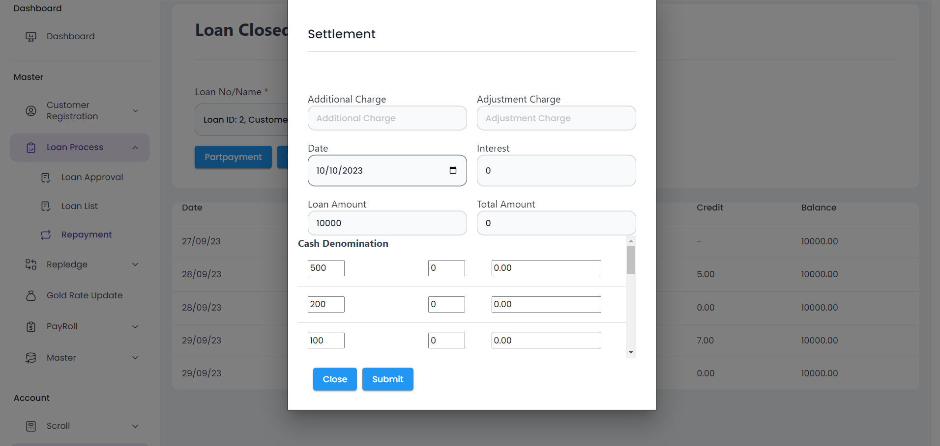

**4.GoldRate**

In the 'Dashboard,' you can access daily gold rate updates. Within the 'Gold Rate Update' section, there are two options: 'Morning Gold Rate' and 'Evening Gold Rate' updates. Each update type includes two variations: '22 Carat' and '24 Carat.' When you click the 'Submit' button, the gold rate will be updated, and the results will be displayed in the 'Dashboard.'

**5.Master**

This is the 'Master Module' section, and its purpose is to allow customers to add data in the UI. When you click the button, a pop-up window will appear, allowing you to enter the data and submit it.

**6.Scroll**

In the 'Scroll' module, there are two submodules: 'Cash Scroll' and 'Transfer Scroll.

**Cash scroll**

In the 'Cash Scroll' submodule, selecting a date displays transactions for that specific day transaction history shown in the table. Clicking the 'Done' button opens the cash denomination page, where the closing amount must match the cash denomination amount.

Transferscroll

In the 'Transfer Scroll' submodule, clicking the 'Credit' button opens a new page with multiple fields for credit-related transactions. After entering the data in the credit fields, the information is displayed on the 'Transfer List' under the credit section.

7.DayBook:

In the 'Daybook' module, when you select a specific date, the transactions for that day are displayed on the table, organized by their respective heads. Additionally, there is a 'Print' button located above the table to print its contents.

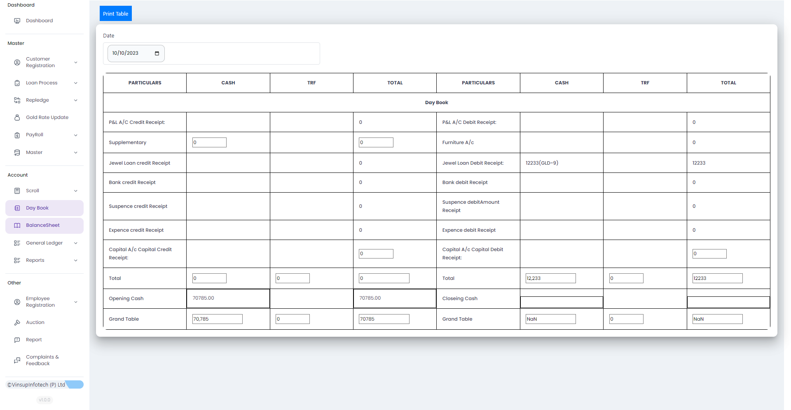  
**8.BalanceSheet**

